**EIAA PTSO Meeting Minutes**

**Nov. 8, 2024 at 11:30 am**

**EIAA, Elko, Nevada**

**President:** Ashley Lavering, **Vice President:** Sashel Wilkinson, **Co-Vice President:** N/A, **Secretary:** Megan Tarbet, **Social Media and Communications Manager:** Vacant. **Treasurer:** Tonya Farr

In attendance: Ashley Lavering, Tonya Farr, Linsey Banford, Angela Crane;///////[[[[[

1. Open Meeting– Ashley opens meeting at 11:41.
   1. Introduction of board members if needed
   2. Please sign up to be members, no obligation to volunteer, we just want you to be in the know and to help when you can. 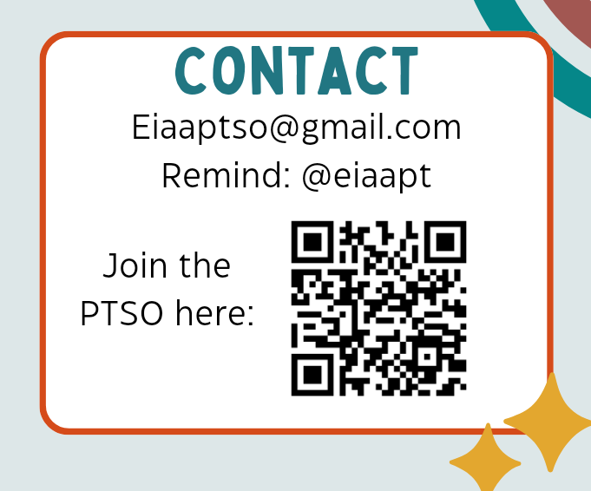
2. Approval of last meetings minutes-

Tonya motions to approve minutes

Ashley seconds motion.

Motion carries.

1. Treasure report- Tonya
   1. Scholastic fair sales and expenditures (suckers).
   2. We sold 902 items, total sales $6463.25.
   3. Fall Carnival - $2,526 with expenditures of 1,810.73 (including the 30% for the D.C. Trip students).
2. Old Business
   1. Book Fair: We earned $3,435.37 in scholastic dollars by hosting the fair.
   2. Fall Carnival:
      1. (Overall profit: ptso 70%, DC kids 30% percentage can increase for DC kids if we have a good profit.) PTSO made 1,267.51 and the D.C. kids will receive $543.22.
   3. Budget approvals. We try to stay as low in these budgets as possible:
      1. Administrative budget: $300
      2. Meeting Snacks: $200
      3. Scholastic Book Fair budget $100
      4. Fall festival budget
      5. The grateful grams for Thanksgiving budget $200
      6. Buckaroo breakfast / cowboy poetry week budget (450 people) $600
      7. Dr Seuss reading week budget/ green eggs and Ham lunch (450 people) $600
      8. Teacher appreciation: $600
      9. Field day: $400
      10. Testing snacks: $400
3. New business:
   1. We need to move to amend the budget for the Fall Festival and approve the extra expenditure. We severely underestimate how much this would cost.

Budget to be increased from $600 to $715. 27

Ashley motions to increase budget.

Tonya seconds motion.

Motion carries.

* 1. We also need to amend the scholastic fair budget to $100 each fair.

Angela motions to approve change to scholastic fair budget.

Linsey seconds motion.

Motion carries.

* 1. Wearth Fundraise from **Oct 10/28–Nov 12th**
     1. Delivery Window: **Dec 3-5.** Tarps needed. Deliver to outside courtyard
     2. Need to count money Nov12 after school. Volunteers?
  2. Grateful Grams-Megan Chair on it.
     1. **11/18-21**—Grateful Grams Purchasing Week (Lunch and hand in to teachers/front office)
     2. **11/25-26**—Grateful Grams Delivered to Students (Please bundle large order for one child)

1. Next Meeting: **Friday Dec 13th at 11:30 am at the EIAA.** We want meetings to be an hour or less. Feel free to mingle a little after meetings to get to know each other.
2. Closing of the meeting - Ashley closes meeting at 12:35.